Blackjack Simulation

An analysis of earnings using simplified strategy

**Jonathan Goldstein**

jgoldstein37@gatech.edu

December 2, 2022

**1. ABSTRACT**

Blackjack is a popular game that is available at every casino in the United States, and as with most casino games, the house mostly has the advantage.1 However, given the correct playing strategy, the casino advantage is less than 1%. This means that the player loses, on average, 1% of the amount wagered. The objective of this analysis is to examine numerous blackjack tactics in R, and identify the strategy(ies) that would yield the highest earnings (or minimize losses). After running over 4,000 unique strategies, the highest earnings are realized when a player participates in 50 continuous hands, wagers $5,000 each hand, and will hit when a hand is less than 13 and when the dealer’s up card is greater than 8. This returns a total net gain of $55,000, with a win percentage of 56%.

**2. RULES**

The object of the blackjack is for a player’s hand total to be greater than the dealer's hand total without going above 21. Before the game begins, the player must place (or “bet”) an initial wager. The game begins when both the player and the dealer are dealt two cards, where the player will initially only see one of the dealer’s cards. The player will then choose whether to hit (take a new card), or stand (reject a new card). Once all the player’s choices are made (stand or going over 21), the player will then be able to see both the dealer’s cards. Until the dealer has a hand totaling 17 or greater, the dealer will hit.

If the player’s hand beats the dealer’s hand, the player will receive 1x their original wager. If the dealer’s hand beats the player’s hand, the player will forfeit their wager. In the event that a player exceeds 21, the dealer wins regardless of the player's own hand. If a player receives an Ace and a card with a value of 10 in the initial deal, that is considered a Blackjack, and the player is awarded 1.5x the original wager. If the player and the dealer both receive the same card total, this is considered a “push”, and the original bet is returned to the player.

**3. GAME ASSUMPTIONS**

Although various strategies were tested and developed as the analysis progressed, initial guidelines were prioritized:

*3.1.* Only one player will be used. Since player hands are simply compared to those of the dealer, adding more players would have only confused the program and had no influence on the game.

*3.2.* Insurance (when the dealer's face-up card is an ace, the player can secure the initial wager with an additional wager of 0.5x) will not be offered as an option.

*3.3.* To limit the influence of card counting, a continuous “shoe” deck will be used with replacement. This is similar to a shoe with a lot of decks that is constantly being reshuffled. The continuously reshuffled shoes that some casinos utilize are comparable to this approach.

*3.4.* This simulation does not consider special rules, such as doubling down, splitting, or surrendering. The simulation created will only utilize Hit vs Stand strategy.

**4. ODDS**

The winning percentage for a blackjack player can vary, however, most players average 42.22%.2 This does not imply that the house always prevails (57.78%)2, mainly due to the event of a tie (8.48%).2 The chances can vary greatly in particular circumstances, largely depending on the blackjack variation (decks used, insurance options, amount of players) and player strategy. For instance, players without a strategy will notice a sharp decline in their chances of winning at blackjack. Because of this, it is best to have basic blackjack strategy in place to give a player better odds, and a sense of when to hit and when to stand.3

**5. STRATEGIES**

Numerous strategies were tested in order to accurately assess the model. These strategies were executed in permutation, meaning every possible combination of inputs were simulated to produce the highest return on wagers. The strategy inputs that were run are as follows:

*5.1. Hand to Hit:* After a player is dealt the initial two cards at the start of the game, what is the sum of both cards in which the player will not hit? For example, if a player is dealt a 15, and Hand to Hit is set at 16, the player will draw another card.

*5.1.1. Hand To Hit values:* The values tested for this variable were: 11, 12 ,13, 14, 15, 16, 17, 18.

*5.2. Dealer Up-Card to Hit:* Given the variable set in 5.1.1, what is the value of the dealer’s up-card that a player will hit? For example, the Dealer Up-Card to Hit is set at 6 and from 5.1.1 Player Hand to Hit is set at 17. In this strategy a player will hit if the dealer’s top card has a value more than 6 and the player's total is less than 17, otherwise the player will stand.

*5.2.1. Dealer Up-Card to Hit values:* The values tested for this variable were: 2, 3, 4, 5, 6, 7, 8, 9.

*5.3. Player Wager:* In order to accurately determine the total amount won by a player, an initial wager, or bet, must be placed by the player. Most casino’s have a minimum and maximum for Blackjack bets ranging from $15 to $5000.

*5.3.1. Player Wager values:* The values tested for this variable were: $15, $25, $50, $100, $200, $500, $1,000, $5,000.

*5.4. Hands to Deal:* The amount of hands that a player will partake until the game ends. Once the Hands to Deal reaches the maximum value, the player will “cash out” and the total winnings will be calculated.

*5.4.1. Hands to Deal values:* The values tested for this variable were: 25, 50, 100, 2,500, 5,000, 10,000, 25,000, 50,000

Since every combination of the variables outlined in 5.2.1 - 5.4.1 were tested, the total number of strategies used in this analysis totaled 4,096. In order to populate these combinations, the following code in Figure 1 was executed:

**6. SIMULATION**

The base structure for the simulation was influenced by Nolan’s Monte Carlo Simulation of gaming structure.2 However, once the logistics were configured, original coding methodologies were used to create all other functionality. In simple terms, the simulation was structured into the follow segments:

*6.1. deck( ), shoe( ) and deck_shuffle( ):* Creates a deck of cards with the numbers they represent, the shoe (combination of decks), and continuous shuffling using replacement.

*6.2. hand_val( )*: As stated in Section 2, initially the player’s hand consists of 2 or more cards. If the total value of those cards exceeds that of the dealer’s hand, but does not exceed 21, then the player wins.2 This function adds up the individual card values and then accounts for the aforementioned unique instances such as blackjack and bust.

*6.3. total_winnings( ):* Uses the amount of the initial wager and whether or not the hand is a blackjack to determine the player's earnings. Knowing the worth of the player's hand, as well as the dealer's hand, is necessary to calculate the total winnings.

*6.4. new_hand( ):* Sets up a basic model for the hand. Since a hand has a bet, a shoe (our function for getting more cards), this functionality creates the 2 card draw at the beginning of the game.

*6.5. hit( ) and stand( ):* Actions for hit (draw another card) and add value to the total sum of card values, or stand (do not draw another card).

*6.6. strategy_simple( ) and dealer_cards( ):* Framework for when a player and dealer need to hit or stand. The player’s strategy is based on the inputs outlined in Section 5, where 4,096 strategies were tested. However, the dealer’s strategy is set by the casino and remains the same throughout the game. This has been outlined in Section 2.

*6.7. play_hand( ):* Functionality to automatically play a game of blackjack, incorporating all parameters from Sections 6.1-6.6. Given that hands of 25-5,000 are tested (Section 5.4.1), the total number of hands initially executed through this function were 47,449,600 (Table 1).

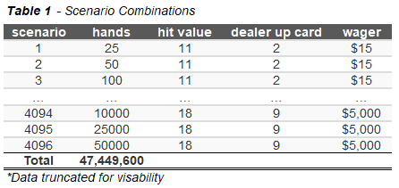

*6.8. best_strategy( ):* The best strategy derived from the results of Section 6.7 was reproduced 50,000 times to test the stress of the strategy’s total winnings (Section 8). With these additional runs, the total play_hands( ), or total simulations, summed ~ 50,000,000 (Table 2).

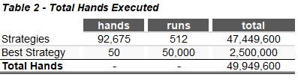

**7. STRATEGY RESULTS**

Full results and instructions on how to run the simulation can be found in the accompanying model files and documentation.

Once the coding methodologies were structured, the simulation was executed, and the best strategy was determined. As visualized in Table 3 below, the strategy that yielded the highest winnings was when the player wagered $5000 per hand, played 50 hands, and hit when the dealer showed a top card greater than 8 and the player had a hand that greater than 13. This returned a total net gain of $55,000, with a win percentage of 56%.

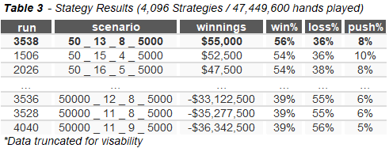

Although win percentages varied greatly, the metric that was most desirable in this simulation was the total return to a player (winnings). Throughout all possible scenarios, a clear theme emerged; the player had the most winnings when the maximum amount was wagered, and the least amount of hands were played. Given that there is a higher probability to lose money when more hands are played, the best strategy involves playing the least amount of hands (25-50 hands per game).

Furthermore, lower Hand to Hit values (Section 5.1.1) yielded lower win percentages and total winnings in the majority of runs. This is because the object of the game is to beat the dealer's hand, therefore a lower hand has a smaller chance of winning.

**8. SIMULATION RESULTS**

After the strategy with the largest net gain was identified, a simulation of 50,000 games was executed. Since the selected strategy consisted of 50 hands, the total amount of hands played for this selected strategy totaled 2,500,000 (Table 2). As presented in Chart 1, the results of the simulation resulted in winnings/losses ranging from +$107,500 to -$157,500. However, when analyzing the results in full, the frequency of losses greatly outweighed that of winnings, as a player is more likely to lose money than win by a degree of 4:1.

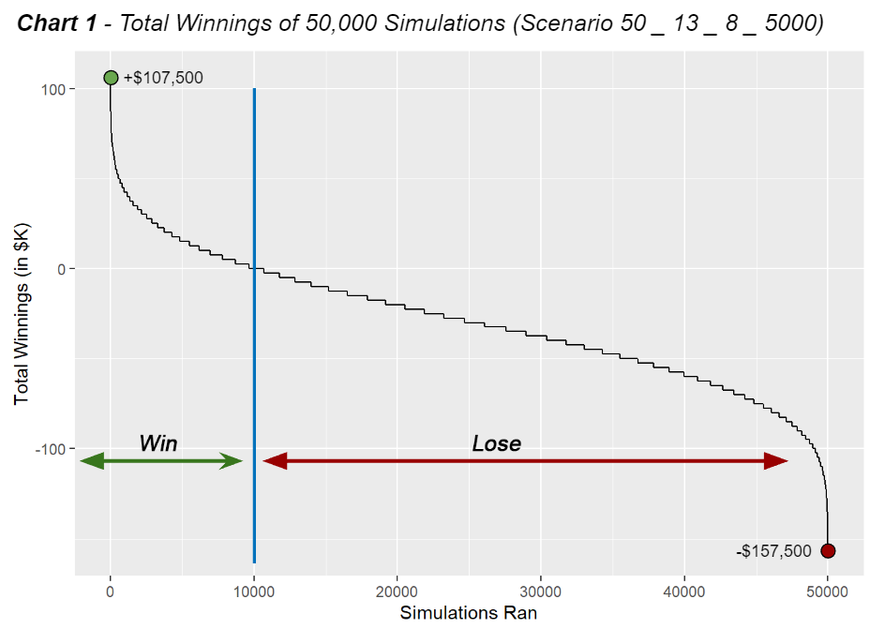

In fact, the mean net amount of winnings for all 50,000 simulations totaled -$29,132, which further proves that the more games played, the less likely a player will return a net positive amount of earnings.

**9. CONCLUSIONS**

After ~5,000,000 individual blackjack hands were simulated, it is evident that implementing a simple strategy will greatly increase the odds of netting positive earnings. As mentioned in Section 4, Millan states that the winning percentage for a blackjack player can vary, however, most players average 42.22%.2 Running the simple strategy outlined in Table 1, increases the winning percentage 12% to 56%. Although a simple strategy can generate positive results, the edge will always be in the casino's favor, and the player is more likely to lose money as more games are played.

**10. DISCUSSION**

The simple strategy outlined in this paper is just one of many utilized by players in an attempt to gain an edge over casinos. Because of this, there are various improvements that can be made to the simulation that could possibly increase a player’s net return. Possible improvements and strategies are outlined below.

*10.1. Improvements:* Add split, insurance and double down functionalities. Almost all casinos in the United States offer these options. Note: the dealer does not have the option to split or double down.

*10.1.1. Splitting Pairs:* Players can decide to regard their first two cards as two unique hands if they are the same value, (ie: the first two cards dealt are two sixes). The initial wager is then placed on one of the cards, and a matching wager must be made on the other card.

*10.1.2. Double Down:* When the player's initial two cards total 9, 10, or 11, they have the option of doubling their wager. When it is the player's turn to wager, they do so with an equal amount to the original bet, and the dealer deals them just one card.

*10.1.3. Insurance:* Any player may place a side wager of up to half their initial wager if the dealer's up-card is an ace (signaling that the dealer might have blackjack). A player can hedge against the risk of a dealer blackjack by “buying” insurance. After the player chooses to buy insurance, the dealer will examine their face down card. If a ten-card is revealed, the players who placed an insurance bet win and receive a payout of two to one (or double the amount of their half-bet). Naturally, the hand is over when the dealer gets a blackjack, and the players' major wagers are collected, unless another player also gets a blackjack in which case it is a stand-off.

*10.1.4. Decks:* Most casinos in the United States use a 4-8 deck shoe and most complicated blackjack strategies are based on this. However, when a finite amount of decks are used, it is easier for a player to cheat by counting cards, which is illegal.

*10.2. Strategy:* There are thousands of blackjack strategies readily available online for players to adhere to when playing a hand. A few examples of such strategies are outlined below, and with minimal code adjustments, could be implemented into the simulation presented in this paper.

*10.2.1.* Always surrender hard 16 against a dealer’s 9, 10, or ace up-card, and hard 15 against dealer’s 10 up-card.3

*10.2.2.* When dealing a pair of 2s or 3s against a dealer’s 2 or 3 up-card, a player should split, and hit if does not have a 2 or 3 up-card.3

*10.2.3.* A player should always double down on an 11 against dealer’s ace, soft 19 (A-8) against dealer’s 6, and A-7 against dealer’s 2.3

*10.2.4.* A player should never split a pair of fives or tens.3

*10.3.* *Betting Systems:* One possible strategy a player could implement is changing their wager following a specific strategy per every hand dealt. There are various strategies that exist, however Martingale and Fibonacci are two of the most prominent.

*10.3.1. Martingale Strategy:* In this betting system, a player doubles their bet after every loss until a win, resulting in a net gain of one betting unit.4 For example, suppose a player wagers $10 and the results of the next three hands are loss, loss, and win (L-L-W). Using the Martingale system, a player lost $10 on the first hand, $20 on the second hand, and won $40 on the third hand. The net gain of the total bets would be one unit, or $10.

*10.3.2. Fibonacci Strategy:* This betting system is based on the Fibonacci Sequence, which was developed by Leonardo Pisan, the Italian mathematician.4 The sequence is as follows: 1, 1, 2, 3, 5, 8, 13, 21, 34, 55, 89 and so on. From this sequence, the pattern that arises is that the next number in the row is the sum of the two previous numbers. Similar to the Martingale Strategy, a player would follow this sequence until a hand is won, and then restart the sequence on the next hand.

Whatever strategy or system a player utilizes, the casino will always have an edge, and therefore, it is most likely best to not play at all. But if one is inclined to gamble, gamble responsibly.

**REFERENCES**

1. The Optimum Strategy in Blackjack. Author(s): Roger R.

Baldwin, Wilbert E. Cantey, Herbert Maisel and James P. McDermott. Source: Journal of the American Statistical Association, Vol. 51, No. 275 (Sep., 1956), pp. 429-439

1. A Statistical Analysis of Casino Blackjack: Martin H.

Millman Source: The American Mathematical Monthly, Vol. 90, No. 7 (Aug. - Sep., 1983), pp. 431-436

1. Henry Tamburin Ph.D: 15 of the Best Blackjack Strategies: October 13, 2021
2. Simon Young: Martingale betting system in roulette and blackjack: A complete guide: September 1st, 2020